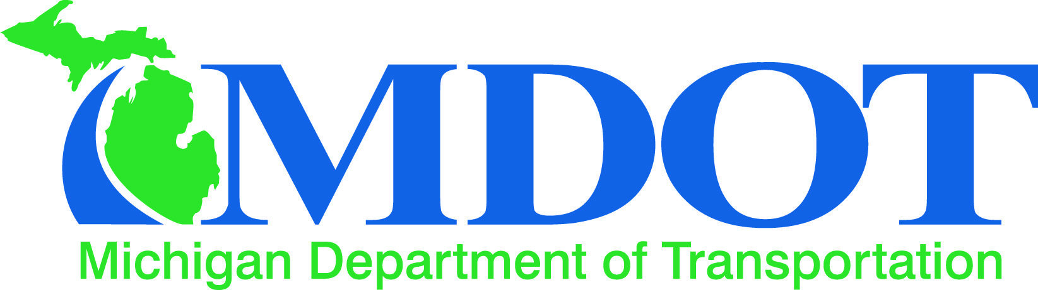
MDOT to Start New Campaign to Better Inform the Public of New and Ongoing Projects
To Current Employees of MDOT Design Division
Why the new campaign?
MDOT already has systems in place to inform the public about projects but feedback from citizens has revealed that many are unaware of such efforts and continue to be left in the dark about projects that may affect their lives. Current efforts include contacting the media and updates on social media pages. The new campaign looks to improve upon these efforts by increasing the visibility and frequency of social media posts as well as branching out into forms of media that are currently underutilized by the department.
What does this mean for me?
This campaign should have little overall effect on any employees' day to day operations though they can expect more requests for project updates from the Office of Communications as well as a greater visibility of their work among the community. Any suggestions from department employees are welcome. Please contact Jacob Zokvic at the Office of Communications about your ideas. We appreciate your support for this new campaign and we hope that you continue to work with us to keep the public informed.
Jacob Zokvic - Office of Communications Phone: 555-5555 E-mail: zokvicj@michigan.gov

